**Spring larval *Coregonus* diets and zooplankton community patterns in the Apostle Islands, Lake Superior**

Verena S. Lucke1,*, Taylor R. Stewart1, Mark R. Vinson2, Jay D. Glase3, Jason D. Stockwell1

1University of Vermont, Rubenstein Ecosystem Science Laboratory, 3 College St., Burlington, VT 05401, USA; Email: [Verena.Lucke@uvm.edu](mailto:Verena.Lucke@uvm.edu), [Taylor.Stewart@uvm.edu](mailto:Taylor.Stewart@uvm.edu), [Jason.Stockwell@uvm.edu](mailto:Jason.Stockwell@uvm.edu); Telephone: 802-656-3009

2 United States Geological Survey, Lake Superior Biological Station, 2800 Lake Shore Drive East, Ashland, Wisconsin 54806, USA; Email: [mvinson@usgs.gov](mailto:mvinson@usgs.gov); Telephone: 715-682-6163

3U.S. National Park Service, 2800 East Lakeshore Drive, Ashland, Wisconsin 54806, USA; Email: [jay_glase@nps.gov](mailto:jay_glase@nps.gov); Telephone:715-682-0631

*Present address: Woods Hole Oceanographic Institution, 45 Water Street, Woods Hole MA 02543

**Abstract**

With the exception of lake whitefish (*Coregonus clupeaformis*), relatively little is known about the early life history larval coregonines in the Laurentian Great Lakes. For example, our knowledge of the feeding ecology of larval coregonines (excluding lake whitefish) is based on only 900 stomachs. We describe the diets and demographics of larval coregonines from post-hatch to approximately 3 months of age, and the contemporaneous zooplankton community, in the Apostle Islands region of Lake Superior in 2018. Exogenous feeding was evident at the smallest size (6 mm). The percentage of larvae with food in their stomachs sharply increased as larvae grew from 10 to 13 mm, and corresponded with a sharp decline in yolk reserves. A majority of the diet items (58%) were copepod nauplii, followed by *Holopedium* (11.4%) and zooplankton eggs (8.1%), with generally positive selection for adult calanoids and cyclopoids, and *Holopedium*. The patterns in exogenous feeding and yolk sac absorption were similar to studies conducted in Lake Superior in the 1970s. Diets were also generally similar, although in 2018 larval coregonines consumed much more *Limnocalanus macrurus*, *Holopedium*, and zooplankton eggs than in the 1970s. The demographic data suggested at least two distinct cohorts and/or species of larval coregonines in the Apostle Islands in 2018. Early life history studies such as reported here, when coupled with emerging genetic techniques that can identify larval coregonines to species, will provide a powerful combination to better understand population dynamics of coregonines at a time of ongoing restoration efforts under changing environmental conditions.

**Keywords**: cisco, bloater, kiyi, recruitment, electivity, Great Lakes

# Introduction

*Coregonus* populations have experienced major stock collapses throughout their range in the mid-20th century (Aronsuu and Huhmarniemi, 2004; Eckmann, 2013; Leach and Nepszy, 1976; Selgeby, 1982; Smith, 1964). Historically, population declines were associated with a number of factors such as habitat alteration, predation, overfishing, and invasive species (Anneville et al., 2015; Christie, 1974; Madenjian et al., 2011; Moffett, 1957; Vonlanthen et al., 2012). In the Laurentian Great Lakes, annual recruitment of coregonines was historically considered constant (Dryer and Beil, 1964; Pritchard, 1931; Smith, 1956; Van Oosten, 1929, 1930). Recent work, however, suggests recruitment is highly variable with occasional strong year classes sustaining populations between multiple years of low to no survival to age-1 (Parks and Rypel, 2018; Stockwell et al., 2009; Yule et al. 2008).

Survival to age-1 is largely dependent on fish surviving from hatch through the first three to six months of life (Cushing, 1968, 1990; Hjort, 1914; Houde, 1987). At this life stage, many size-dependent processes strongly influence growth and survival, including swimming speed, visual acuity, yolk-sac energy reserves, gape-limited foraging, and predation (Miller et al., 1988). When such processes are integrated, seemingly small differences in size and growth rate may profoundly shape larval survival and the success or failure of a year-class (Miller et al., 1988; Rice et al. 1993).

Diet is central to many of the mechanisms thought to influence larval fish survival. Diet composition and consumption are functions of prey availability, which interact with temperature to determine growth and ultimately ties into size- and growth-dependent processes (Crowder et al., 1987; Houde, 1989, Miller et al., 1988). In the case of Great Lakes coregonines, numerous studies have examined larval lake whitefish (*C. clupeaformis)* diets (e.g., Hoyle et al., 2011; Johnson et al., 2009; Pothoven, 2019), but diets of other coregonines at the larval stage are poorly understood, especially in light of recent shifts in food web structure (Barbiero et al., 2012; Bunnell et al., 2013; Nalepa et al., 2009), re-oligotrophication (Barbiero et al., 2011; Evans et al., 2011; Fahnenstiel et al., 2010), and current and expected trends in climate and their potential impacts on lake habitat (Austin and Colman, 2007, 2008; Matsumoto et al., 2019; O’Reilly et al., 2015; Ye et al., 2019). Our knowledge of larval coregonine diets outside of lake whitefish is based on the contents of 900 stomachs, with most information several decades old (Anderson and Smith, 1971; Eppehimer et al., 2019; Savino et al., 1994; Selgeby et al., 1994).

In this study, we describe the demographics and diets of larval coregonines in the Apostle Islands region of Lake Superior in spring and early summer of 2018. Fisheries management plans in the Great Lakes include coregonine restoration and rehabilitation, and basic information on early life history is necessary to support such efforts (Bronte et al., 2017; Muir et al., 2012; Zimmerman and Krueger, 2009). We examined diets relative to larval length, yolk condition, and zooplankton community composition, and report on length at first-feeding, the relationship between feeding and yolk-sac absorption, and selection of zooplankton prey larval coregonines consumed from spring into summer. We conclude with a comparison of our results to those from a similar study conducted in this area in 1974 by Selgeby et al. (1994).

# Methods

## Study System

The Apostle Islands form an archipelago of 21 near-shore islands located in the western arm of Lake Superior (Fig. 1). The archipelago is a nursery ground for coregonines and the site of two previous studies focused on larval cisco (*Coregonus artedi*) diets (Anderson and Smith, 1971; Selgeby et al., 1994).

## Sample Collection

Samples were collected between 0700 and 1500 local time between 14 May, shortly after ice out, and 25 July 2018. Ten sites were sampled throughout the northern and central areas of the Apostle Islands (Fig. 1). Sites were divided into two groups of five based on proximity to one another and their relative location within the islands, with each group sampled on a different day each week. Sampling site order and days varied across weeks due to weather constraints, such that each site was sampled at a variety of times during the day throughout the sampling period. Larval fish were sampled using a bongo net with paired 0.5-m diameter conical nets and 500-µm mesh. The net was towed approximately 15 m behind the vessel, with the top of the net frame just visible at the surface. Tow duration was 10 minutes on a straight transect with an average speed of 4.6 km/h (range: 2.4-6.1 km/h). Surface water temperature was taken shortly after the net was deployed along the transect. Tow direction and heading was determined by positioning the wind at the stern of the vessel to go across a fixed transect midpoint. Tows had an average start depth of 26.5 m (range: 4.3 - 67.7 m), average end depth of 24.3 m (range: 2.3 - 69.5 m), and average distance of 0.8 km (range: 0.4 - 1.8 km). All larval fish collected were immediately counted and preserved in 90% ethanol. A single surface zooplankton sample was collected with a 0.5-m diameter conical net with 63-µm mesh immediately following each larval fish tow. The zooplankton net was deployed for one minute over the same transect between the endpoint and midpoint such that the vessel faced directly into the wind. Zooplankton were immediately concentrated and preserved in 90% ethanol.

## Zooplankton Density and Biomass

## Zooplankton were identified, counted, and measured until 200 individuals were enumerated from a known sample volume or 2% of the sample volume had been examined, whichever came first. Zooplankton were classified to genus with the exception of nauplii. The estimated number of individuals per sample was then divided by the estimated sample volume, assuming 100% net efficiency, to estimate density (individuals/L). Lengths were digitally recorded at 10X under an Olympus SZX dissecting scope equipped with a calibrated digitizing tablet. A maximum of 30 copepod nauplii were measured per sampleand any additional nauplii were counted. Individual lengths were converted to individual mass for each taxon (Bottrell et al., 1976; Burgess et al., 2015), and average mass was then multiplied by density to estimate biomass for each taxa at each site and date.

## Genus-specific minimum adult lengths were used to differentiate adult copepods and copepodites in the zooplankton samples to match the taxonomic resolution of the larval diet data (Ewers, 1930; Hawkins and Evans, 1979). The entirety of each sample was visually examined for large-bodied cladocerans and mysids. When Leptodora kindti, Bythotrephes longimanus, or Mysis were present, all individuals within the sample were counted and up to 30 individuals were measured. Density and biomass for large-bodied taxa were estimated in the same manner as described above.

## Larval Diet Composition

In the laboratory, larval fish were identified as coregonines or other (Auer, 1982). All larval coregonines were counted, individually photographed, measured to the nearest 0.01 mm using a dissecting scope equipped with a camera (Leica Application Suite), and recorded as having yolk sac present or absent. Occasionally, larval coregonines were found in the zooplankton samples and those individuals were combined with the other larvae collected at that site and date. Larval lengths were binned into 1-mm length classes by site and date.

Stomachs were removed and presence or absence of food noted for each fish. When food was present, we pooled stomach contents for all individuals within a length class collected from that site and date. All food items were counted and classified to the lowest possible taxonomic resolution. Copepodites were identified as calanoid or cyclopoid. The percentage of larvae with a yolk sac and stomach content presence was calculated for each 1-mm length class at each site and date to determine if larvae fed prior to full yolk-sac absorption and to estimate the length when larvae began to feed exogenously.

## Larval Coregonine Diet Electivity

Selective predation by larval coregonines was determined by comparing the stomach contents from a given date and site to their corresponding zooplankton sample. Because the number of taxa in zooplankton samples and stomachs varied across sites and weeks, we expressed selectivity using relativized electivity 𝐸i* (Vanderploeg and Scavia, 1979a,b):

where *n* is the number of prey taxa present in the environment, *i* is the *i*th prey taxon, and *Wi* is:

In this instance, *Wi* is equivalent to αi (Chesson, 1978), where *ri* is the proportion of prey taxon *i* in the diet and *pi* is the proportion of prey taxon *i* in the environment. The index varies with both the number of prey types available and the ratio *ri* /*pi* , ranging from 1 to -1. *Ei\** values > 0 indicate positive selection, < 0 indicate negative selection, and 0 indicates neutral or random selection (Vanderploeg and Scavia, 1979a,b). The non-linear relationship between *Wi* and *Ei\** allowed us to characterize selectivity even as the available types of prey and their relative abundances changed over time (Confer and Moore, 1987; Lechowicz, 1982). *Wi* was assumed to be equal to 1 for all samples where taxa were found in the diet but not in the corresponding zooplankton sample. Because the maximum value of *Ei\** varies with the number of taxa available, a value of 1 can only be achieved under impossible conditions, where *ri*  = 1 and *pi* = 0 for a single taxon and the number of available taxa is infinite. To provide additional clarity to this analysis, we chose to include a threshold for each week of sampling which indicates the greatest possible value of *Ei\** given the finite number of taxa available.

# Results

## Water temperature at the surface ranged from 3.2-19.6°C during the study period (Table S1). Surface water temperatures fluctuated from week to week and across sites, though generally temperature increased over time and all sites experienced a similar range of temperatures.

## Zooplankton

Zooplankton density and biomass increased approximately 7- and 20-fold between the first and last few weeks of sampling, but weekly average total density and biomass across all sites never exceeded 6 individuals L-1 and 7 µg dry L-1, respectively (Fig. 2; Table S2; Table S3). Numerically, copepod nauplii were the dominant taxon, with some increase in copepodite and adult stages of calanoids (*Leptodiaptomus*, *Epischura*, and *Limnocalanus*) and cyclopoids (*Acanthocyclops*, *Diacyclops*, and *Mesocyclops*) in the latter half of the sampling period and a noticeable increase in cladocera (*Bosmina*, *Diaphanosoma*, and *Holopedium*) in the final two weeks (Fig. 2). Despite their numerical dominance, nauplii composed ≥ 50% of the total biomass in only 2 of the 11 weeks. Most weeks, calanoids and cyclopoids composed the majority of biomass, although cladocera reached nearly 50% of total biomass by the last week of sampling (Fig. 2). *Daphnia* were present for more than half the sampling weeks but did not compose a substantial portion of the zooplankton community, and *B. longimanus* was only found in the last three weeks of sampling.

## Larval fish

A total of 629 larval coregonines were caught over the 11 weeks of sampling. Larval coregonines were captured each week of sampling but the catches were highly variable, ranging from 7 to 206 (Fig. 3). Larval lengths ranged from 6.7 - 26.2 mm. The smallest individuals were captured in both early June and mid-July (Fig. 3), suggesting different hatch dates among cohorts or different *Coregonus* species. Overall, our sampling appeared to track a cohort between the first collections in May through early July; after which the length-frequency distribution spread and became more uniform as new 6-10 mm individuals joined the population (Fig. 3). The newly-hatched individuals in July precluded tracking individual cohorts and calculating growth rates.

## Diet Composition

A total of 623 larval coregonine stomachs were in suitable condition to be examined, 478 of which contained food. More than 20,000 prey items were enumerated and identified (Table 1). Most fish < 11 mm had empty stomachs, whereas most fish ≥ 12 mm contained food (Fig. 4). By numbers, nauplii dominated larval coregonine diets throughout the sampling period, accounting for more than 55% of all prey items (Table 1, Fig. 5). The dominant diet item in May was invertebrate eggs, which composed 84% of all diet items found in larvae stomachs at this time (Fig. 5) and overlapped with a relative increase in adult calanoid copepods in mid-May in surface tows (Fig. 2). Invertebrate eggs also tended to be more prevalent in smaller larvae during the first month of sampling; eggs were close to 50% of diet composition for length bins 10-12 mm, but declined to 0% at 17 mm (Fig. 6). During July, cladocera made up a greater portion of diets by numbers compared to earlier months, with *Holopedium* alone accounting for > 11% of the overall diet during this period, including > 60% of the diet in the last week of sampling (Fig. 5). *Holopedium* was primarily found in stomachs of larger larvae, typically > 17 mm (Fig. 6). The number of cyclopoids found in larval coregonine stomachs also increased in the later months, corresponding to the increase observed in cyclopoid biomass in surface tows, particularly *Diacyclops* (Figs. 2, 5, 6). *Limnocalanus*, one of the largest copepods in the Lake Superior zooplankton community, occurred more frequently in the larval diet than in the zooplankton surface tows. In particular, we found *Limnocalanus* in fish stomachs from about half (53) of all ichthyoplankton tows, compared to only 16 zooplankton tows. The predatory cladocerans *B. longimanus* and *L.* *kindti* were relatively rare in both numbers consumed (15 and 12 individuals total, respectively) and frequency of occurrence (4% and 2%, respectively).

Only 32% of 148 larvae captured in May had food present in their stomachs when zooplankton density and biomass were low and larvae were relatively small. However, 95% of 169 captured larvae had food in their stomachs in July when zooplankton were more abundant and larval coregonines spanned a greater length range than in May (Figs. 2, 3). The larvae that did feed in the first two weeks of sampling in May had relatively few items per stomach compared to fish from later weeks (Fig. 5); larval fish stomachs contained an average (± SE) of 10.0 ± 5.7 prey items per stomach during the first two weeks of sampling compared to 88.9 ± 44.2 prey items per stomach during the final two weeks of July.

## Larval Yolk Condition and Feeding

A subset of 431 larvae were examined to determine if endogenous energy reserves and exogenous feeding overlapped and to estimate the length when larvae began feeding exogenously. Almost 100% of larvae < 11 mm had a yolk sac, and more than 75% of them had empty stomachs (Fig. 4). The percent of larvae with food in their stomachs increased from 18% at 10 mm to > 75% at 12 mm, while the percent with yolk sacs decreased from 97% to < 20% over the same length interval. These trends continued such that all larvae > 16 mm had fully absorbed yolk sacs and food in their stomachs.

## Electivity trends

Larval coregonines exhibited a wide range of electivities for copepods. Adult calanoids and cyclopoids were positively or neutrally selected nearly every week, whereas cyclopoid copepodites were generally negatively or neutrally selected (Fig. 7). Although copepod nauplii were the most abundant and most frequently consumed prey taxon (Figs. 2, 5), their *E\** estimates were negative during May and early June, positive in June, and then neutral in July (Fig. 7). For cladocera, *Diaphanosoma* was generally positively selected, whereas *Bosmina* was negatively selected, and *Daphnia* and *Holopedium* electivities were variable, ranging from positive to neutral to negative (Fig. 7).

# Discussion

Larval coregonines appear able to withstand extended periods after hatch without feeding. The relatively smooth increase in gut contents and concurrent decrease in yolk-sac presence from 6 to 14 mm suggest larvae have a wide “window of opportunity” to begin exogenous feeding, and thus resistance to starvation (Miller et al., 1988). In laboratory studies, larval cisco from Lake Mendota recovered from 18 days of starvation (John and Hasler, 1956) and larval bloater from Lake Michigan did not reach 50% mortality until > 25 days of starvation (Rice et al., 1987a). The relatively low frequency of occurrence of food in the gut and the number of prey items per stomach in May compared to June, despite similar zooplankton densities and biomass in the two months, suggests larval coregonines were unable to feed efficiently after hatch or did not need to feed immediately after hatch while endogenous resources were available. The general pattern we observed was nearly identical to that reported in the Apostle Islands and Black Bay, Lake Superior, in 1974 (Selgeby et al., 1994) and in the St. Marys River in 1992 (Savino et al., 1994). Collectively, the period between hatch and 13-14 mm may represent a critical time for first feeding in larval coregonines.

Diet composition in 2018 was generally consistent with earlier studies in Lake Superior and the St. Marys River that found copepods, and in particular nauplii, the dominant prey for larval coregonines (Anderson and Smith, 1971; Savino et al., 1994; Selgeby et al., 1994). However, we found three major exceptions - invertebrate eggs, *Holopedium*, and *Limnocalanus* were common diet items in 2018 but virtually absent in larval fish in 1974 (Table 1). Invertebrate eggs were a dominant prey in May 2018, and although we did not conclusively identify the eggs, they were characteristic of copepod eggs at a time when fecund adult calanoid copepods increased in our zooplankton nets. Zooplankton eggs may represent a relatively easy meal for larval fish because they lack an escape response to predators. The absence of *Holopedium* in 1974 diets could be a result of an earlier termination of sampling (3 July) compared to 2018 (25 July), or increases in *Holopedium* abundance between the 1970s and more recent periods (Brown and Branstrator, 2004). Unlike the summer-dependent *Holopedium*, *Limnocalanus* is a coldwater species that overlaps with larval coregonines from hatch. In 2018, *Limnocalanus* was a frequent and generally positively-selected diet item throughout the entire sampling period and the predominant adult calanoid copepod in the diet. In 1974, sampling for both larvae and zooplankton in the Apostle Islands covered the entire water column, but few *Limnocalanus* (12 total) were found in over 700 stomachs that contained food (Selgeby et al., 1994) compared to 2018 (> 850 total *Limnocalanus* in < 500 stomachs). Interestingly, *Limnocalanus* was absent in surface zooplankton tows for three of the last four weeks of sampling in 2018, suggesting larval coregonines were not feeding exclusively at the surface during our sampling. Coregonine larvae can be vertically separated from prey during the day (Eckmann, 1989; Ventling-Schwank and Meng, 1995), which would confound our estimates of electivities. Nevertheless, our comparison of *Limnocalanus* in the diets of larval coregonines, for these two specific sampling campaigns separated by 34 years, suggests a stark contrast in the availability of the adult stages of this important, large-bodied calanoid to larval coregonines in the Apostle Islands region.

The patterns of zooplankton community composition and seasonal change, as assessed by our surface tows from mid-May to the end of July, were as expected (Barbiero et al., 2019; Brown and Branstrator, 2004; Selgeby, 1975). In May, the community was dominated by copepods, especially nauplii by numbers and calanoids by biomass. Starting in mid-June, calanoid and cyclopoid copepodites increased in both density and biomass until peaking mid-July when cladocerans, especially *Holopedium*, sharply increased. The consistent presence of adult calanoids in both larval coregonine guts and the environment throughout the sampling period, and their positive/neutral selection by larvae, suggest adult calanoids are an important prey taxon, especially given the larger body mass of calanoids compared to smaller prey taxa. Larval coregonines also showed positive selection for *Holepedium* when the relatively large-bodied cladoceran started to become abundant in July, further confirming larvae preference for larger taxa. Similarly, adult calanoids are an important component of adult cisco diets in Lake Superior, particularly in winter and spring, as are cladoceran prey in summer and fall (Dryer and Beil, 1964; Gamble et al., 2011a,b; Link et al., 1995; Rosinski et al., in press). Our results, combined with observations of adults, suggest diets of cisco are fairly consistent across much of their life. Bloater (*C. hoyi*) and kiyi (*C. kiyi)* tend to consume the macroinvertebrates *Diporeia* and *Mysis* at older life-stages in Lake Superior (Gamble et al., 2011a,b; Rosinski et al., in press), such that these species must undergo an ontogenetic diet switch between the larval and older life stages.

A cohort of larval coregonines was evident during the first week of sampling, and was easily tracked until mid-June. By the end of June and in mid-July, we observed an increase in the smallest-sized coregonines (down to 6 mm), suggesting a second cohort of larval coregonines. While larval cisco are found in surface waters after hatch in spring in Lake Superior (Hatch and Underhill, 1988; Myers et al., 2008), larval bloater in Lake Michigan appear in surface waters starting in June or July and continue through August (Rice et al., 1987b). Virtually nothing is known about the early life history of the other coregonines in Lake Superior, including kiyi and shortjaw cisco (*C. zenithicus*). Genomic sequencing of a subset of larvae from the current study indicated that larval coregonines comprised a mix of cisco, kiyi, and bloater throughout the sampling period, with a general temporal sequence of cisco followed by kiyi and then bloater (Lachance, 2019). Our gut and genetic analyses were pooled in such a way that we could not trace diets back to genetically-identified individuals. Future studies will be able to take advantage of genetic tools (Ackiss et al., 2019; Lachance 2019) to identify larvae to species to examine similarities and differences of early life ecology among coregonine species, including diet, growth, and mortality.

Lake Superior ice and water temperature dynamics have changed over the past two decades, resulting in decreased ice cover, increased lake surface temperatures during the summer months, and longer periods of summer stratification (Matsumoto et al., 2019, Van Cleave et al. 2014, Austin and Colman, 2007, 2008). As thermal regimes and winter ice cover shift, thermal cues which may influence coregonine spawning in autumn, egg incubation and development over winter, and time of hatching in spring have the potential to alter early life phenology, including earlier hatch times leading to generally smaller larvae with a larger yolk supply (Karjalainen et al., 2015, 2016). Similar and non-linear shifts in zooplankton community composition and trajectories are also likely with shifting lake phenology (Pawlowski et al., 2018; Winder and Schindler, 2004a,b). The spatial and temporal overlap of larval coregonines and plankton resources under such shifting phenologies, and the consequences for recruitment, are difficult to predict. Long-term monitoring of zooplankton community composition, larval fishes and their diet, and abiotic conditions during spring into summer will provide opportunities to evaluate the importance of the match-mismatch hypothesis (Cushing, 1990; Houde, 1987) when contrasting year-class strengths have been observed.

Basic information about the early life history of coregonines is necessary to support current coregonine restoration and rehabilitation efforts in the Great Lakes (Bronte et al., 2017; Muir et al., 2012; Zimmerman and Krueger, 2009). While we have provided additional and contemporary information on larval coregonine diets, additional research will be needed to inform restoration and management decisions. Changes in environmental conditions may present a stark challenge to larvae at the time of hatch, especially if these shifts impact the duration of the incubation period, hatch timing, and seasonal zooplankton community trajectories.

# Acknowledgements

We thank Lori Evrard, Ted Gostomski, and Nathan Klein for assisting with field sampling, Hannah Lachance for collaborating on laboratory techniques, and Rosaura Chapina, Jonathan Doubek, and Sayde Goldfarb for assisting with zooplankton analysis. XXXX provided U.S. Geological Survey solicited reviews that strengthened the manuscript, as did anonymous peer reviewers. Any use of trade, product, or firm names is for descriptive purposes only and does not imply endorsement by the U.S. Government. This article is contribution XXXX of the U.S. Geological Survey Great Lake Science Center.

# References

Ackiss, A.S., Larson, W.A., Stott, W., 2019. Genotyping-by-sequencing illuminates high levels of divergence among sympatric forms of coregonines in the Laurentian Great Lakes. bioRxiv doi: https://doi.org/10.1101/784355

Anderson, E.D., Smith Jr., L.L., 1971. Factors affecting abundance of lake herring (*Coregonus artedii Lesueur*) in western Lake Superior. Trans. Am. Fish. Soc. 100, 691–707.

Anneville, O., Yule, D.L., Eckmann, R., Lasne, E., Stockwell, J.D., Gillet, C., Guillard, J., 2015. Fishing and stocking practices promote fish diversity loss. Food and Nutrition Sciences (Special Issue on Fisheries, Aquaculture and Environment) 6, 1045-1055.

Aronsuu, K., Huhmarniemi, A., 2004. Changes in the European whiteﬁsh (*Coregonus lavaretus* (L.)) population of the Kalajoki — potential consequences of the alterations of ﬁshing patterns in the Gulf of Bothnia. Ann. Zool. Fenn. 41, 195–204.

Auer, N.A., 1982. Identification of larval fishes of the Great Lakes basin with emphasis on the Lake Michigan drainage. Great Lakes Fish. Comm., Special Publication 82-3, Ann Arbor, Michigan.

Austin, J.A., Colman, S.M., 2007. Lake Superior summer water temperatures are increasing more rapidly than regional air temperatures: A positive ice-albedo feedback. Geophys. Res. Lett. 34, L06604.

Austin, J.A., Colman, S.M., 2008. A century of temperature variability in Lake Superior. Limnol. Oceanogr. 53, 2724–2730.

Auvinen, H., Kolari, I., Pesonen, A., Jurvelius, J., 2004. Mortality of 0+ vendace (*Coregonus albula*) caused by predation and trawling. Ann. Zool. Fenn. 41, 339-350.

Barbiero, R.P., Rudstam, L.G., Watkins, J.M., Lesht, B.M., 2019. A cross-lake comparison of crustacean zooplankton communities in the Laurentian Great Lakes, 1997–2016. J. Great Lakes Res. 45, 672-690.

Barbiero, R.P., Lesht, B.M., Warren, G.J., 2011. Evidence for bottom–up control of recent shifts in the pelagic food web of Lake Huron. J. Great Lakes Res. 37, 78-85.

Barbiero, R.P., Lesht, B.M., Warren, G.J., 2012. Convergence of trophic state and the lower food web in Lakes Huron, Michigan and Superior. J. Great Lakes Res. 37, 78-85.

Bottrell, H.H., Duncan, A., Gliwicz, M.Z., Grygierek, E., Herzig, A., Hillbricht-Ilkowska, A., Kurasawa, H., Larsson, P., Weglenska, T., 1976. A review of some problems in zooplankton production studies. Norwegian J. Zool. 24, 419-456.

Bronte, C.R., Bunnell, D.B., David, S.R., Gordon, R., Gorsky, D., Millard, M.J., Read, J., Stein, R.A., Vaccaro, L., 2017. Report from the workshop on coregonine restoration science. U.S. Geological Survey. Available from: <https://pubs.usgs.gov/of/2017/1081/ofr20171081.pdf>

Brown, M.E., Branstrator, D.K., 2004. A 2001 survey of crustacean zooplankton in the western arm of Lake Superior. J. Great Lakes Res. 30, 1–8.

Bunnell, D.B., Mychek-Londer, J.G., Madenjian, C.P., 2014. Population-level effects of egg predation on a native planktivore in a large freshwater lake. Ecol. Freshw. Fish 23, 604–614.

Bunnell, D.B., Barbiero, R.P., Ludsin, S.A., Madenjian, C.P., Warren, G.J., Dolan, D.M., Brenden, T.O., Briland, R., Gorman, O.T., He, J.X., Johengen, T.H., Lantry, B.F., Lesht, B.M., Nalepa, T.F., Riley, S.C., Riseng, C.M., Treska, T.J., Tsehaye, I., Walsh, M.G., Warner, D.M., Weidel, B.C., 2013. Changing ecosystem dynamics in the Laurentian Great Lakes: bottom-up and top-down regulation. BioScience 64, 26-39.

Burgess, S., Jackson, E.W., Schwarzman, L., Gezon, N., Lehman, J.T., 2015. Improved estimates of calanoid copepod biomass in the St. Lawrence Great Lakes. J. Great Lakes Res. 41, 484-491.

Chesson, J. 1978. Measuring preference in selective predation. Ecology 59, 211-215.

Christie, W.J., 1974. Changes in the fish species composition of the Great Lakes. J. Fish. Res. Board Can. 31, 827-854.

Confer, J.L., Moore, M.V., 1987. Interpreting selectivity indices calculated from field data or conditions of prey replacement. Can. J. Fish. Aquat. Sci. 44, 1529–1533.

Crowder, L.B., McDonald, M.E., Rice, J.A., 1987. Understanding recruitment of Lake Michigan fishes: the importance of size‐based interactions between fish and zooplankton. Can. J. Fish. Aquat. Sci. 44, s141–s147.

Cushing, D.H., 1968. Direct estimation of a fish population acoustically. J. Fish. Res. Board Can. 25, 2349-2364.

Cushing, D.H., 1990. Plankton production and year-class strength in fish populations: an update of the match/mismatch hypothesis. Adv. Mar. Biol. 26, 249-293.

Dryer, W.R., Beil, J., 1964. Life history of lake herring in Lake Superior. U.S. Fish and Wildlife Service Fishery Bulletin 63, 493–530.

Eckmann, R., 1989. The distribution of coregonid larvae (*Coregonus lavaretus* and *C. fera*) from Lake Constance in a vertical temperature gradient. Pol. Arch. Hydrobiol. 36, 485-494.

Eckmann, R., 2013. A review of the population dynamics of coregonids in European alpine lakes. Adv. Limnol. 64, 3–24.

Eppehimer, D.E., Bunnell, D.B., Armenio, P.M., Warner, D.M., Eaton, L.A., Wells, D.J., Rutherford, E.S., 2019. Densities, diets, and growth rates of larval alewife and bloater in a changing Lake Michigan ecosystem. Trans. Am. Fish. Soc. 148, 755–770.

Evans, M.A., Fahnenstiel, G., Scavia, D., 2011. Incidental oligotrophication of North American Great Lakes. Environ. Sci. Technol. 45, 3297–303.

Ewers, L.A., 1930. The larval development of freshwater copepods. The Ohio State Univ. Frantz Theodore Stone Lab. Contr. No. 3, 1-43.

Fahnenstiel, G.L., Nalepa, T.F., Pothoven, S.A., Carrick, H.J., Scavia, D., 2010. Lake Michigan lower food web: long-term observations and *Dreissena* impact. J. Great Lakes Res. 36 (Suppl. 3), 1–4.

Gamble, A.E., Hrabik, T.R., Stockwell, J.D., Yule, D.L., 2011a. Trophic connections in Lake Superior Part I: The offshore fish community. J. Great Lakes Res. 37, 541–549.

Gamble, A.E., Hrabik, T.R., Yule, D.L., Stockwell, J.D., 2011b. Trophic connections in Lake Superior Part II: The nearshore fish community. J. Great Lakes Res. 37, 550–560.

Hatch, J.T., Underhill, J.C., 1988. Abundance, distribution, growth, and mortality of larval lake herring in western Lake Superior. Am. Fish. Soc. Symp. 5, 96–103.

Hawkins, B.E., Evans, M.S., 1979. Seasonal cycles of zooplankton biomass in southeastern Lake Michigan. J. Great Lakes Res. 5, 256–263.

Hjort, J., 1914. Fluctuations in the great fisheries of Northern Europe viewed in the light of biological research. Rapp. Conserv. Explor. Mer. 20, 1–228.

Houde, E.D., 1987. Fish early life dynamics and recruitment variability. Am. Fish. Soc. Symp. 2, 17–29.

Houde, E.D., 1989. Comparative growth, mortality, and energetics of marine fish larvae: temperature and implied latitudinal effects. Fish. Bull. 87, 471-495.

Hoyle, J.A., Johannsson, O.E., Bowen, K.L., 2011. Larval lake whitefish abundance, diet and growth and their zooplankton prey abundance during a period of ecosystem change on the Bay of Quinte, Lake Ontario. Aquat. Ecosys. Health Manage. 14, 66–74.

John, K.R., Hasler, A.D., 1956. Observations on some factors affecting the hatching of eggs and the survival of young shallow-water cisco, *Leucichthys artedi* LeSueur, in Lake Mendota, Wisconsin. Limnol. Oceanogr. 1, 176-194.

Johnson, J.H., McKenna, J.E., Chalupnicki, M.A., Wallbridge, T., Chiavelli, R., 2009. Feeding ecology of lake whitefish larvae in eastern Lake Ontario. J. Great Lakes Res. 35, 603–607.

Karjalainen, J., Auvinen, Helminen, H., Marjomäki, T.J., Niva, T., Sarvala, J., Miljanen, M. 2000. Unpredictability of fish recruitment: interannual variation in young-of-the-year abundance. J. Fish Biol. 56, 837-857.

Karjalainen, J., Keskinen, T., Pulkkanen, M., Marjomäki, T.J., 2015. Climate change alters the egg development dynamics in cold-water adapted coregonids. Environ. Biol. Fish. 98, 979–991.

Karjalainen, J., Jokinen, L., Keskinen, T., Marjomäki, T.J., 2016. Environmental and genetic effects on larval hatching time in two coregonids. Hydrobiol. 780, 135–143.

Leach, J.H., Nepszy, S.J., 1976. The fish community in Lake Erie. J. Fish. Res. Board Can. 33, 622–638.

Lechowicz, M.J., 1982. The sampling characteristics of electivity indices. Oecologia 52, 22–30.

Lachance, H., 2019. Cisco science: using omics to answer a range of key questions. Master’s Thesis, University of Vermont.

Link, J., Selgeby, J.H., Hoff, M.H., Haskell, C., 1995. Winter diet of lake herring (*Coregonus artedi*) in western Lake Superior. J. Great Lakes Res. 21, 395-399.

Madenjian, C.P., Rutherford, E.S., Blouin, M.A., Sederberg, B.J., Elliott, J.R. 2011. Spawning habitat unsuitability: an impediment to cisco rehabilitation in Lake Michigan? N. Am. J. Fish. Manage. 31, 905-913.

Matsumoto, K., Tokos, K.S., Rippke, J., 2019. Climate projection of Lake Superior under a future warming scenario. J. Limnol. 78, 296-309.

Miller, T.J., Crowder, L.B., Rice, J.A., Marschall, E.A., 1988. Larval size and recruitment mechanisms in fishes: toward a conceptual framework. Can. J. Fish. Aquat. Sci. 45, 1657–1670.

Moffett, J. W. 1957. Recent changes in the deep‐water fish populations of Lake Michigan. Trans. Am. Fish. Soc. 86, 393-408.

Muir, A.M., Bronte, C.R., Mida Hinderer, J.L., Dettmers, J.M., Krueger, C.C., 2012. Fourth reintroduction of native fishes workshop. Great Lakes Fish. Comm. Available from: <http://www.glfc.org/pubs/2012_GLFC_Native_Fishes_Workshop_Report_Linked.pdf>

Myers, J.T., Stockwell, J.D., Jones, M.L., Yule, D.L., Black, J.E., 2008. Evaluating sampling strategies for larval cisco (*Coregonus artedi*). J. Great Lakes Res. 34, 245-252.

Myers, J.T., Yule, D.L., Jones, M.L., Ahrenstorff, T.D., Hrabik, T.R., Claramunt, R.M., Ebener, M.P., Berglund, E.K., 2015. Spatial synchrony in cisco recruitment. Fish. Res. 165, 11–21.

Nalepa, T.F., Fanslow, D.L., Lang, G.A., 2009. Transformation of the offshore benthic community in Lake Michigan: recent shift from the native amphipod *Diporeia* spp. to the invasive mussel *Dreissena rostriformis bugensis*. Freshw. Biol. 54, 466–479.

O’Reilly, C.M., Sharma, S., Gray, D.K., Hampton, S.E., Read, J.S., Rowley, R.J., et al., 2015. Rapid and highly variable warming of lake surface waters around the globe. Geophys. Res. Lett. 42, 10773-10781.

Parks, T.P., Rypel, A.L., 2018. Predator–prey dynamics mediate long-term production trends of cisco (*Coregonus artedi* ) in a northern Wisconsin lake. Can. J. Fish. Aquat. Sci. 75, 1969–1976.

Pawlowski, M.B., Branstrator, D.K., Hrabik, T.R., 2018. Major shift in the phenology of crustacean biomass in western Lake Superior associated with temperature anomaly. J. Great Lakes Res. 44, 788–797.

Pothoven, S.A., 2019. The influence of ontogeny and prey abundance on feeding ecology of age‐0 lake whitefish (*Coregonus clupeaformis*) in southeastern Lake Michigan. Ecol. Freshw. Fishes 29, 103-11.

Pritchard, A.L., 1931. Taxonomic and life history studies of the ciscoes of Lake Ontario. University of Toronto Press, Toronto.

Rice, J.A., Crowder, L.B., Binkowski, F.P., 1987a. Evaluating potential sources of mortality for larval bloater (*Coregonus hoyi*) starvation and vulnerability to predation. Can. J. Fish. Aquat. Sci. 44, 467-472.

Rice, J.A., Crowder, L.B., Holey, M.E., 1987b. Exploration of mechanisms regulating larval survival in lake michigan bloater: a recruitment analysis based on characteristics of individual larvae. Trans. Am. Fish. Soc. 116, 703–718.

Rice, J.A., Miller, T.J., Rose, K.A., Crowder, L.B., Marschall, E.A., Trebitz, A.S., Deangelis, D.L., 1993. Growth rate variation and larval survival: inferences from an individual-based size-dependent predation model. Can. J. Fish. Aquat. Sci. 50, 133–142.

Rosinski, C.L., Vinson, M.R., Yule, D.L., In press. Niche partitioning among native ciscoes and non-native rainbow smelt in Lake Superior. Trans. Am. Fish. Soc.

Savino, J.F., Blouin, M.A., Davis, B.M., Hudson, P.L., Todd, T.N., Fleischer, G.W., 1994. Effects of pulsed turbidity and vessel traffic on lake herring eggs and larvae. J. Great Lakes Res. 20, 366–376.

Selgeby, J.H., 1975. Life histories and abundance of crustacean zooplankton in the outlet of Lake Superior, 1971-72. J. Fish. Res. Board Can. 32, 461-470.

Selgeby, J.H., 1982. Decline of lake herring (*Coregonus artedii*) in Lake Superior: an analysis of the Wisconsin herring fishery, 1936–78. Can. J. Fish. Aquatic Sci. 39, 554–563.

Selgeby, J.H., MacCallum, W.R., Hoff, M.H., 1994. Rainbow smelt–larval lake herring interactions: competitors or casual acquaintances? U.S. National Biological Survey, Biological Report 25.

Smith, S.H., 1956. Life history of lake herring of Green Bay, Lake Michigan. U.S. Fish and Wildlife Service Fishery Bulletin 57, 87–138.

Smith, S. H., 1964. Status of the deepwater cisco population of Lake Michigan. Trans. Am. Fish. Soc. 93, 155-163.

Stockwell, J.D., Ebener, M.P., Black, J.A., Gorman, O.T., Hrabik, T.R., Kinnunen, R.E., Mattes, W.P., Oyadomari, J.K., Schram, S.T., Schreiner, D.R., Seider, M.J., Sitar, S.P., Yule, D.L., 2009. A Synthesis of Cisco Recovery in Lake Superior: Implications for Native Fish Rehabilitation in the Laurentian Great Lakes. N. Am. J. Fish. Manag. 29, 626–652.

Van Cleave, K., Lenters, J.D., Wang, J. and Verhamme, E.M., 2014. A regime shift in Lake Superior ice cover, evaporation, and water temperature following the warm El Niño winter of 1997–1998. Limnol. Oceanogr. 59, 1889-1898.

Van Oosten, J., 1929. Life history of the lake herring (*Leucichthys artedi* Le Sueur) of Lake Huron as revealed by its scales, with a critique of the scale method. U.S. Bureau of Fisheries Bulletin 44, 265–428.

Van Oosten, J., 1930. The disappearance of the Lake Erie cisco — a preliminary report. Trans. Am. Fish. Soc. 60, 204–214.

Ventling-Schwank, A.R. Meng, H.J. 1995. Vertical migration of coregonid larvae in the first two months of development. Aquat. Sci. 57, 1-13.

Vonlanthen, P., Bittner, D., Hudson, A.G., Young, K.A., Müller, R., Lundsgaard-Hansen, B., Roy, D., Di Piazza, S., Largiader, C.R., Seehausen, O., 2012. Eutrophication causes speciation reversal in whitefish adaptive radiations. Nature 482, 357–362.

Vanderploeg, H. A., Scavia, D., 1979a. Calculation and use of selectivity coefficients of feeding: zooplankton grazing. Ecol. Model. 7, 135–149.

Vanderploeg, H.A., Scavia, D., 1979b. Two electivity indices for feeding with a special reference to zooplankton grazing. J. Fish. Res. Board Can. 36, 362-365.

Winder, M., Schindler, D.E., 2004a. Climate change uncouples trophic interactions in an aquatic ecosystem. Ecology 85, 2100-2106.

Winder, M., Schindler, D.E., 2004b. Climate effects on the phenology of lake processes. Glob. Change Biol. 10, 1844-1856.

Ye, X., Anderson, E.J., Chu, P.Y., Huang, C., Xue, P., 2019. Impact of water mixing and ice formation on the warming of Lake Superior: A model-guided mechanism study. Limnol. Oceanogr. 64, 558–574.

Yule, D.L., Stockwell, J.D., Black, J.A., Cullis, K., Cholwek, G., Myers, J.T., 2008. How systematic age underestimation can impede understanding of fish population dynamics: lessons learned from a Lake Superior cisco stock. Trans. Am. Fish. Soc. 137, 481–495.

Zimmerman, M.S., Krueger, C.C., 2009. An ecosystem perspective on re-establishing native deepwater fishes in the Laurentian Great Lakes. N. Am. J. Fish. Manag. 29, 1352–1371.

Table 1: Diet composition of 728 larval coregonine stomachs collected between 6 May and 7 July 1974 (Selgeby et al. 1994) and 623 stomachs collected between 14 May and 25 July 2018 (this study) in the Apostle Islands, Lake Superior.

|  |  |  |  |  |  |
| --- | --- | --- | --- | --- | --- |
| Food Item Taxon | 1974 | |  | 2018 | |
| Total No. of Items | Percent of total items |  | Total No. of Items | Percent of total items |
| Copepod *Nauplii* | 1501 | 63.0% |  | 11682 | 57.7% |
| *Holopedium gibberum* |  |  |  | 2309 | 11.4% |
| Invertebrate eggs |  |  |  | 1637 | 8.1% |
| Calanoid Copepoditea | 401 | 16.8% |  | 1199 | 5.9% |
| Unidentified Calanoid |  |  |  | 915 | 4.5% |
| *Limnocalanus macrurus* | 3 | 0.1% |  | 860 | 4.3% |
| Cyclopoid Copepoditeb | 221 | 9.3% |  | 522 | 2.6% |
| Unidentified Cyclopoid |  |  |  | 466 | 2.3% |
| *Diacyclops thomasi*c | 2 | 0.1% |  | 276 | 1.4% |
| *Daphnia* sp. | 4 | 0.2% |  | 113 | 0.6% |
| *Bosmina* sp. | 1 | <0.1% |  | 65 | 0.3% |
| *Leptodiaptomus minutus* |  |  |  | 27 | 0.1% |
| Rotifera | 3 | 0.1% |  | 21 | 0.1% |
| *Eucyclops* sp. |  |  |  | 21 | 0.1% |
| *Epischura lacustris* | 1 | <0.1% |  | 20 | 0.1% |
| *Chironomid* pupae |  |  |  | 20 | 0.1% |
| *Acanthocyclops* sp. |  |  |  | 16 | <0.1% |
| *Leptodiaptomus sicilis*d | 4 | 0.2% |  | 15 | <0.1% |
| *Bythotrephes longimanus* |  |  |  | 15 | <0.1% |
| *Leptodora kindti* |  |  |  | 12 | <0.1% |
| *Diaphanosoma sp.* |  |  |  | 10 | <0.1% |
| *Senecella calanoides* |  |  |  | 8 | <0.1% |
| *Leptodiaptomus ashlandi*d | 227 | 9.5% |  |  |  |
| *Notholca* sp. | 8 | 0.3% |  |  |  |
| *Acroperus harpae* | 3 | 0.1% |  |  |  |
| *Polyphemus pediculus* | 2 | 0.1% |  |  |  |
| Total | 2381 | 99.8% |  | 20229 | 99.6% |

a Originally noted "*Diaptomus* sp. - immature"

b Originally noted "Unidentified Cyclopoida Copepoda - immature"

c  Taxonomic change, originally noted "*Cyclops bicuspidatus thomasi*"

d Taxonomic change, originally noted "*Diaptomus sicilis*", "*Diaptomus ashlandi*"

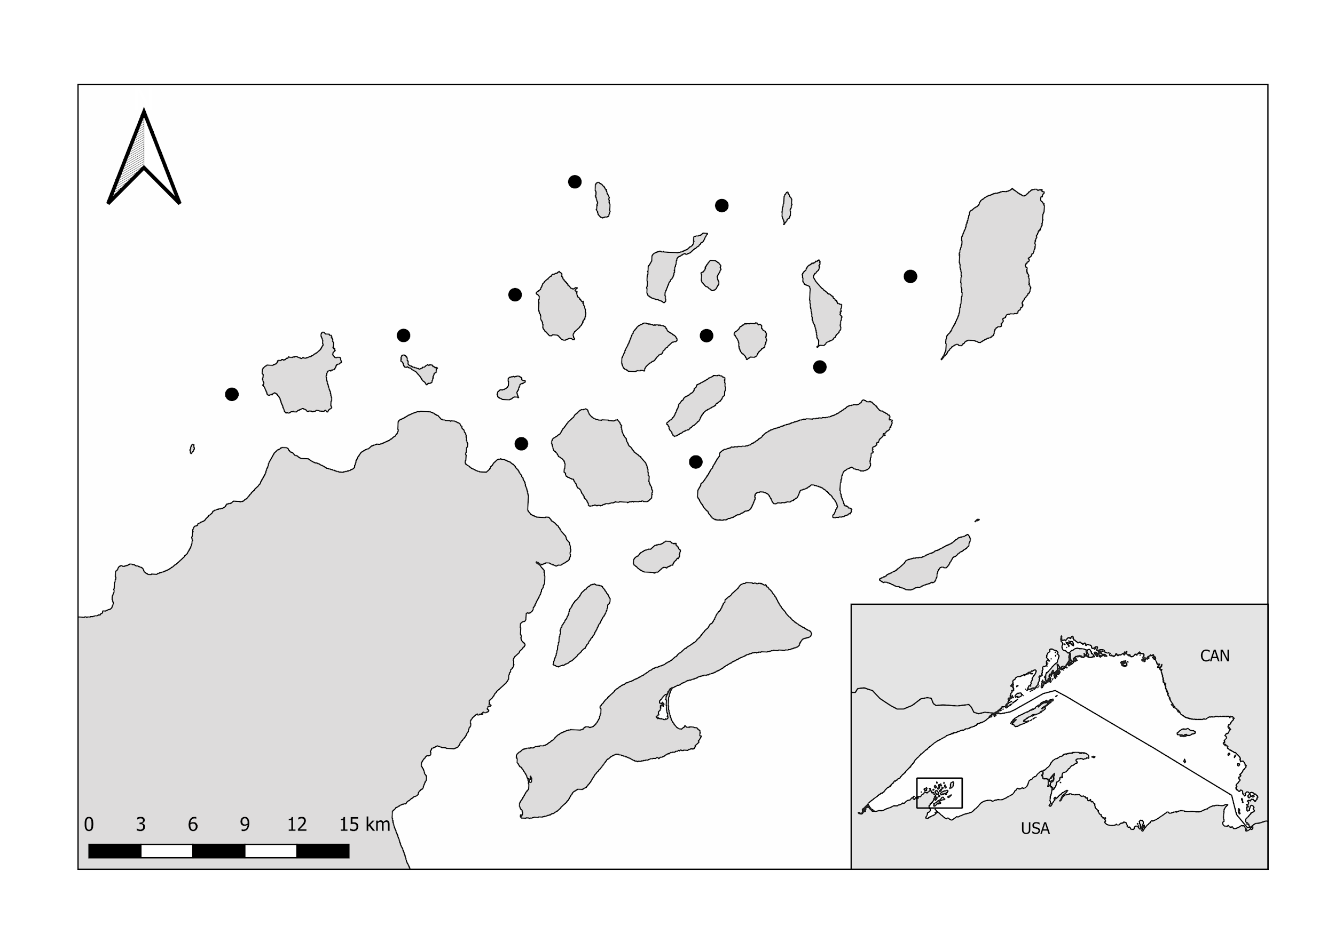

Fig. 1: Larval fish and zooplankton sampling locations in the Apostle Islands region of Lake Superior. Samples were collected between 14 May and 25 July 2018.

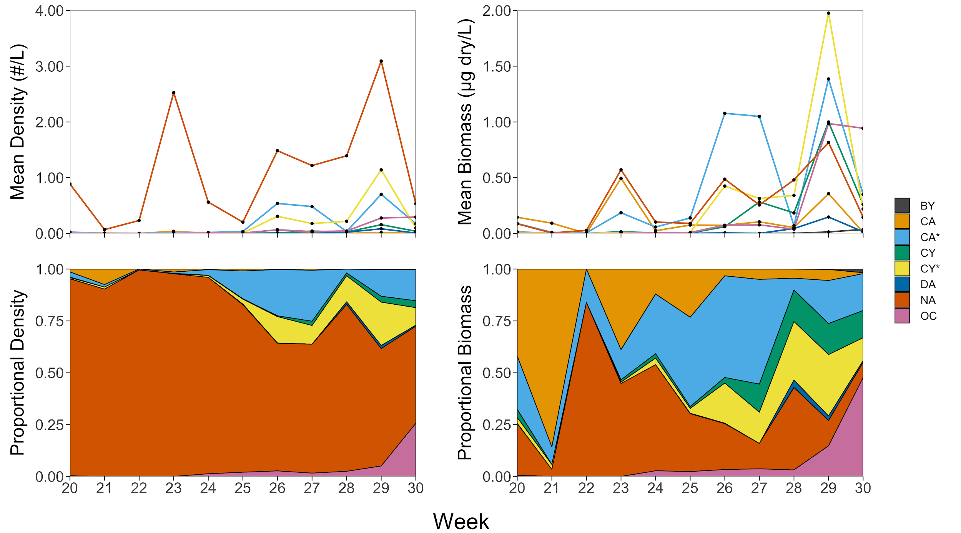

Fig. 2. Mean density and biomass, and their proportions, of zooplankton taxa captured in surface tows between 14 May (Week 20) and 23 July (Week 30) 2018 in the Apostle Islands region of Lake Superior. BY = *Bythotrephes longimanus*, CA = Calanoida , CA* = Calanoid Copepodites, CY = Cyclopoida, CY* = Cyclopoid Copepodites, DA = *Daphnia*,NA = nauplii, and OC = Other Cladocerans.

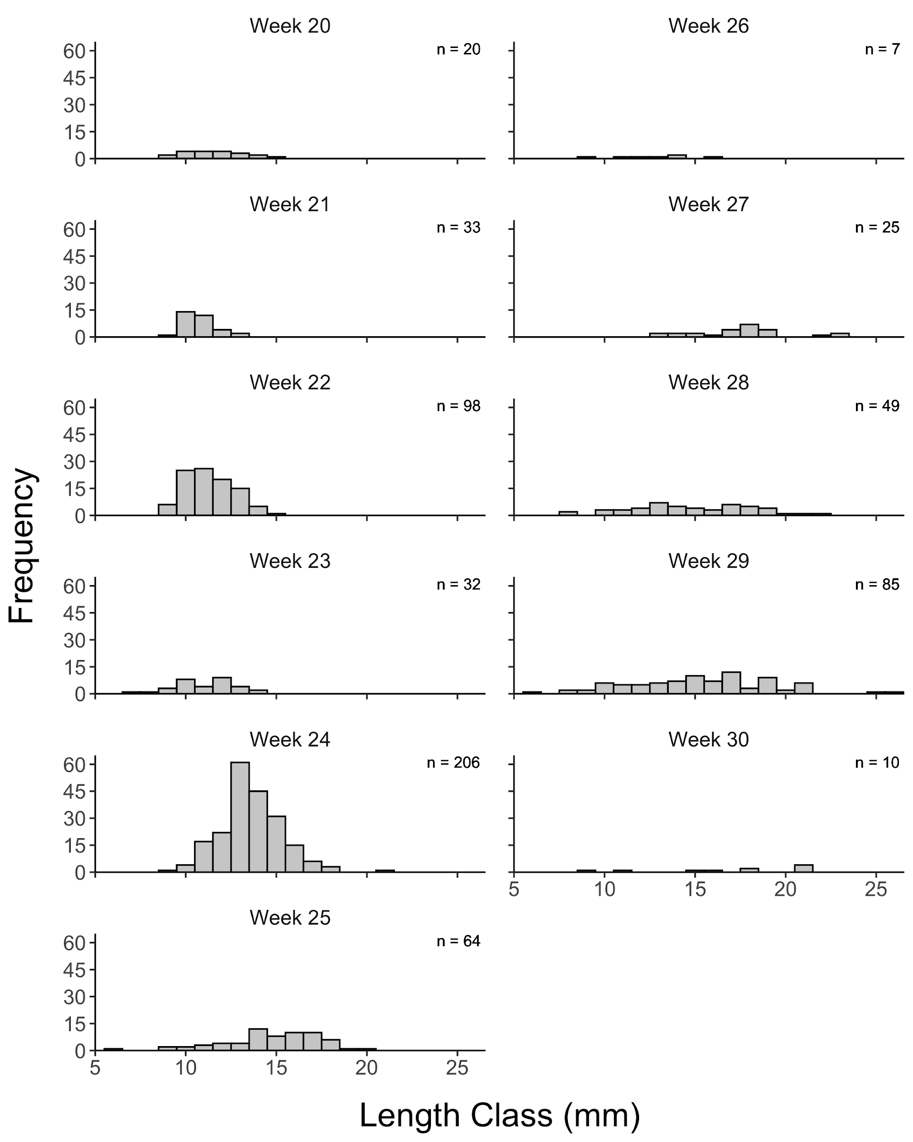

Fig. 3. Weekly length distributions of all larval coregonines collected in the Apostle Islands region of Lake Superior in 2018. With the exception of week 3 (n = 5 sites), all sites (n = 10) were sampled each week. Weekly total catch is indicated in the top right corner of each panel.

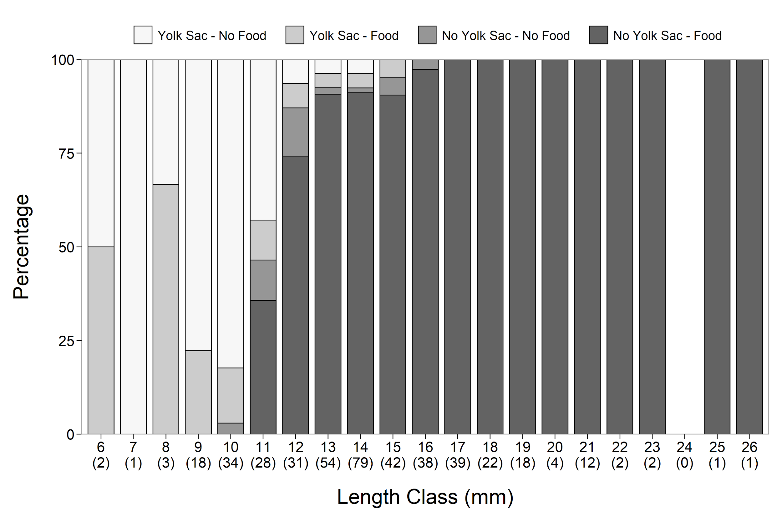

Fig. 4. Percentage of yolk-sac presence/absence and food presence/absence in each 1-mm length class of larval coregonines collected in the Apostle Islands region of Lake Superior in 2018. Sample size is indicated in parentheses and represents the subsample of individuals examined in each length class. No larvae were present in the 24-mm length class.

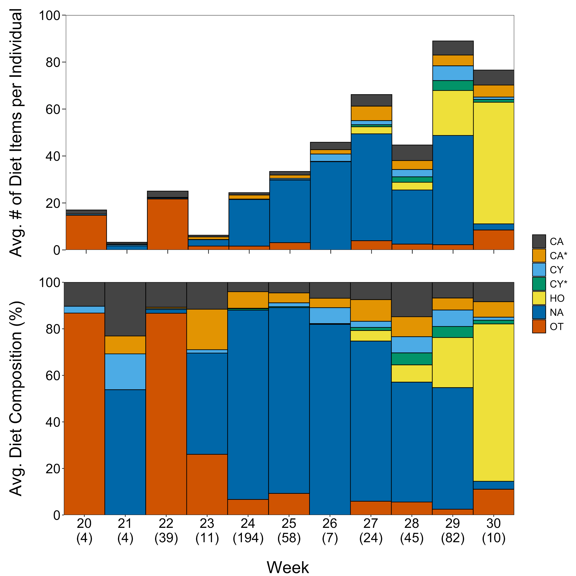

Fig. 5. (Upper panel) Average number of diet items in larval coregonines with food present in their gut, pooled by week. (Lower panel) Average percent diet composition (numerical) of larval coregonines with food present in the gut, pooled by week. Sample size (number of larvae with food in their stomachs) indicated in parentheses for each week. OT = other taxa including invertebrate eggs, *Chironomid* pupae, rotifers, andall cladocera except *Holopedium*. See Figure 2 for other abbreviations.

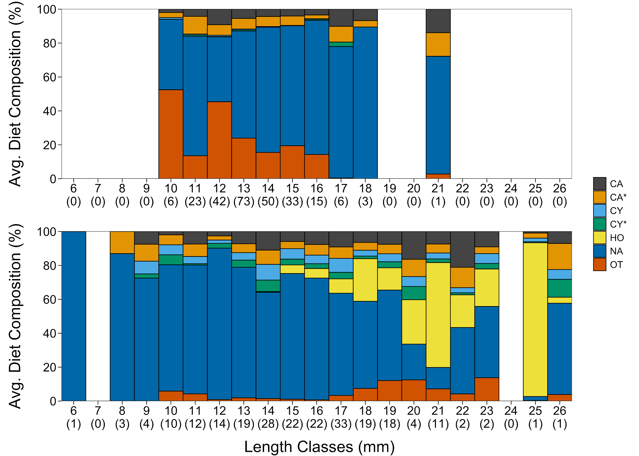

Fig. 6. Percent diet composition by number as a function of length for weeks 20-24 (May 14 to June 13, 2018; upper panel) and weeks 25-30 (June 18 to July 25, 2018; lower panel). Sample size (number of larvae with food in their stomachs) indicated in parentheses for each length bin. See Figures 2 and 5 for abbreviations.

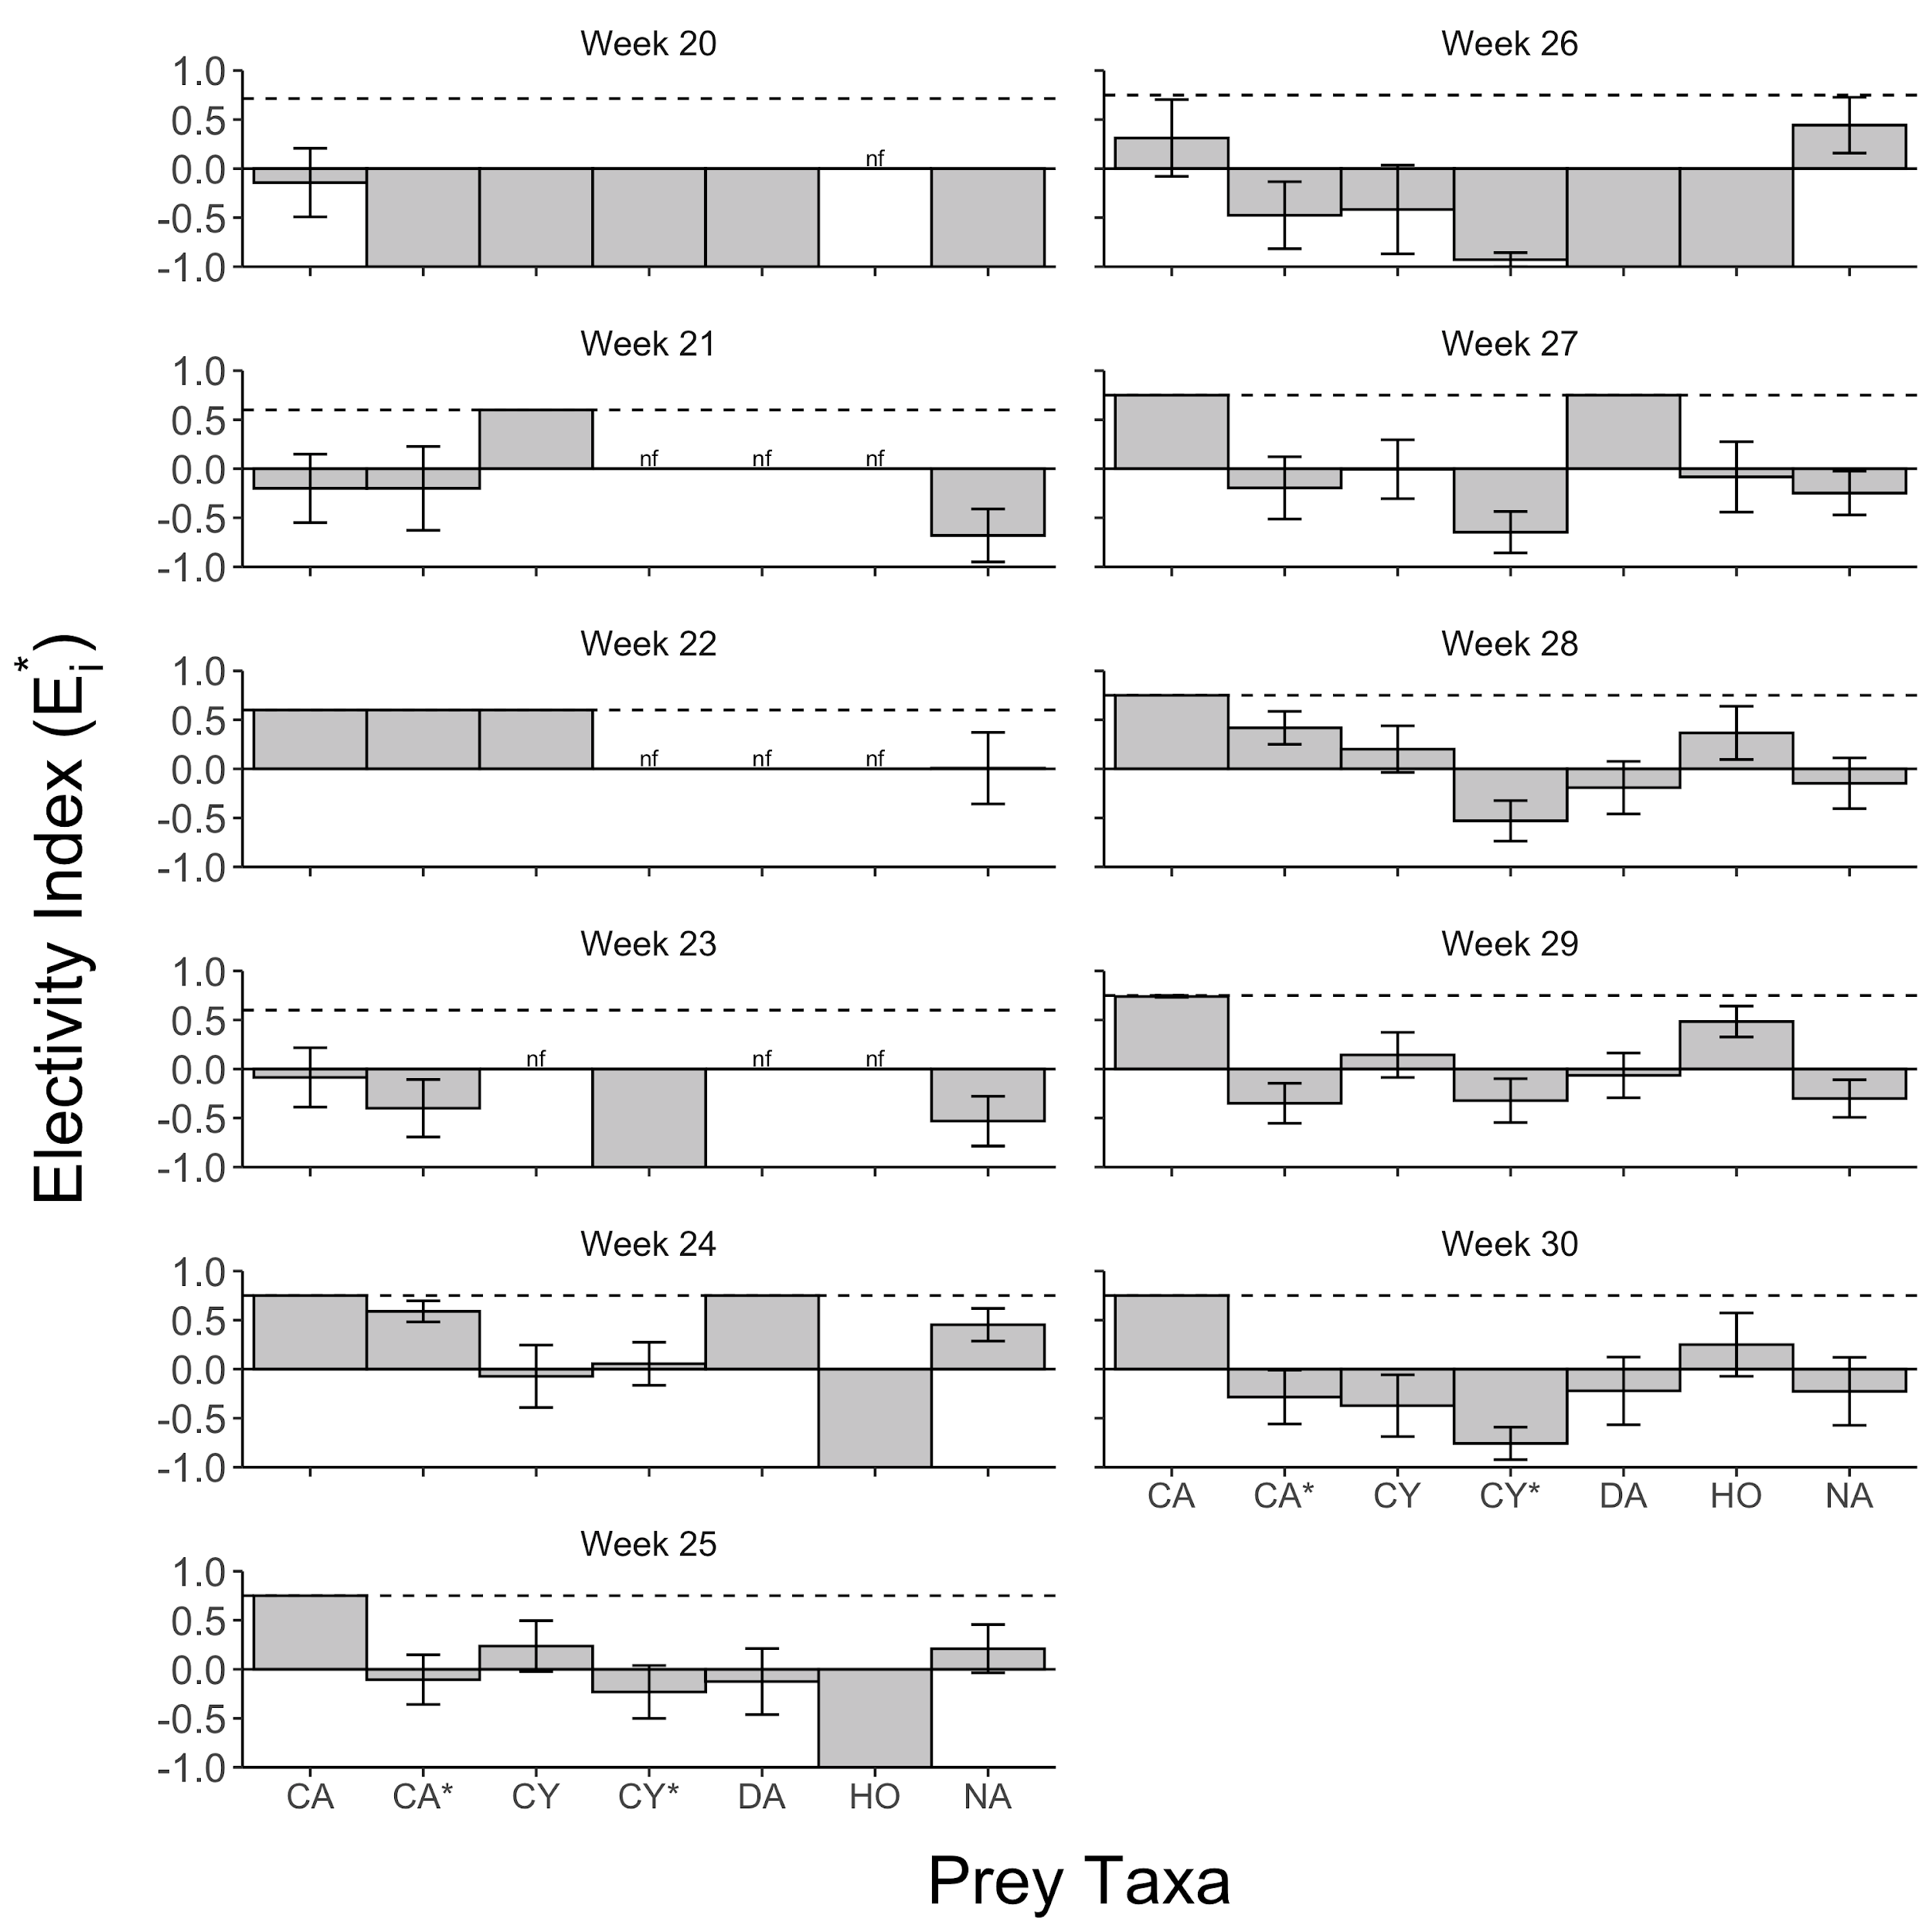

Fig. 7. Average (± SE) *E\** for each prey taxon for each week of sampling. Dashed lines represent the maximum positive selection possible based on the number of taxa present in each week. Taxa not found during a given week are denoted with *nf*. HO = *Holopedium*. See Figure 2 for other abbreviations.

Table S1: Mean surface water temperature pooled across sites by week.

|  |  |  |
| --- | --- | --- |
| Week | Mean Temperature (°C) | Standard Deviation (°C) |
| 20 | 4.17 | 0.84 |
| 21 | 6.80 | 1.37 |
| 22 | 9.02 | 2.66 |
| 23 | 5.76 | 0.64 |
| 24 | 8.20 | 0.97 |
| 25 | 12.57 | 1.69 |
| 26 | 11.11 | 2.19 |
| 27 | 12.06 | 1.92 |
| 28 | 16.14 | 1.40 |
| 29 | 17.36 | 1.17 |
| 30 | 17.70 | 0.86 |

Table S2: Mean density (#/L) of zooplankton taxa captured in surface tows between 14 May (Week 20) and 23 July (Week 30) 2018 in the Apostle Islands region of Lake Superior. See Figure 2 for other abbreviations.

|  |  |  |  |  |  |  |  |  |  |  |  |
| --- | --- | --- | --- | --- | --- | --- | --- | --- | --- | --- | --- |
|  | Week | | | | | | | | | | |
| Taxon | 20 | 21 | 22 | 23 | 24 | 25 | 26 | 27 | 28 | 29 | 30 |
| BY | 0 | 0 | 0 | 0 | 0 | 0 | 0 | 0 | <0.001 | <0.001 | <0.001 |
| CA* | 0.023 | 0.001 | 0.001 | 0.017 | 0.016 | 0.034 | 0.538 | 0.481 | 0.032 | 0.701 | 0.172 |
| CA | 0.013 | 0.006 | 0 | 0.037 | 0.002 | 0.002 | 0.006 | 0.011 | 0.001 | 0.016 | 0.001 |
| CY* | 0.005 | 0.001 | 0 | 0.003 | 0.005 | 0.006 | 0.306 | 0.176 | 0.217 | 1.140 | 0.096 |
| CY | 0.002 | 0 | 0 | 0.002 | 0.001 | 0.001 | 0.010 | 0.041 | 0.024 | 0.156 | 0.038 |
| DA | 0.001 | 0 | 0 | 0 | 0 | 0.001 | 0.003 | 0 | 0.022 | 0.081 | 0.006 |
| NA | 0.886 | 0.068 | 0.231 | 2.526 | 0.561 | 0.202 | 1.483 | 1.217 | 1.392 | 3.093 | 0.533 |
| OC | 0.003 | 0 | 0 | 0 | 0.008 | 0.005 | 0.065 | 0.031 | 0.043 | 0.275 | 0.292 |

Table S3: Mean biomass (µg dry/L) of zooplankton taxa captured in surface tows between 14 May (Week 20) and 23 July (Week 30) 2018 in the Apostle Islands region of Lake Superior. See Figure 2 for other abbreviations.

|  |  |  |  |  |  |  |  |  |  |  |  |
| --- | --- | --- | --- | --- | --- | --- | --- | --- | --- | --- | --- |
|  | Week | | | | | | | | | | |
| Taxon | 20 | 21 | 22 | 23 | 24 | 25 | 26 | 27 | 28 | 29 | 30 |
| BY | 0 | 0 | 0 | 0 | 0 | 0 | 0 | 0 | 0.001 | 0.013 | 0.035 |
| CA* | 0.089 | 0.009 | 0.005 | 0.185 | 0.057 | 0.138 | 1.078 | 1.050 | 0.069 | 1.386 | 0.351 |
| CA | 0.144 | 0.092 | 0 | 0.494 | 0.024 | 0.074 | 0.072 | 0.104 | 0.053 | 0.356 | 0.009 |
| CY* | 0.010 | 0.003 | 0 | 0.008 | 0.006 | 0.007 | 0.425 | 0.313 | 0.341 | 1.976 | 0.219 |
| CY | 0.014 | 0 | 0 | 0.015 | 0.004 | 0.003 | 0.060 | 0.282 | 0.183 | 0.999 | 0.260 |
| DA | <0.001 | 0 | 0 | 0 | 0 | 0.001 | 0.005 | 0 | 0.043 | 0.147 | 0.015 |
| NA | 0.086 | 0.004 | 0.028 | 0.570 | 0.102 | 0.090 | 0.487 | 0.255 | 0.480 | 0.816 | 0.145 |
| OC | 0.002 | 0 | 0 | 0 | 0.005 | 0.008 | 0.073 | 0.076 | 0.038 | 0.986 | 0.943 |